Module II Ethernet

Ethernet :
Ethernet is a family of computer networking techno10gies commonly used LANs & MANs. It was commercially introduced in 1980 and was first standardized in 1983 as IEEE 802.3
Ethernet is a link layer protocol in the TCP/IP stack, describing how networked devices can format data for transmission to other network devices on the same network segment, how to put that data out on the network connection.
It touches the physical layer the data link layer on the OSI network protocol model.
Ethernet defines two units of transmission, packet and frame.
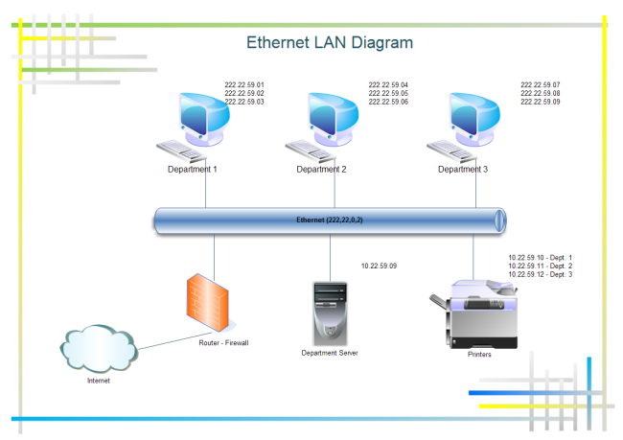
The frame includes not just the "pay10ad" of data being transmitted but also addressing information identifying the physical "Media Access Control" (MAC) addresses of both sender and receiver, VLAN tagging and quality of service information, and error-correction information to detect problems in transmission.
Each frame is wrapped in a packet, which affixes several bytes of information used in establishing the connection and marking where the frame starts.
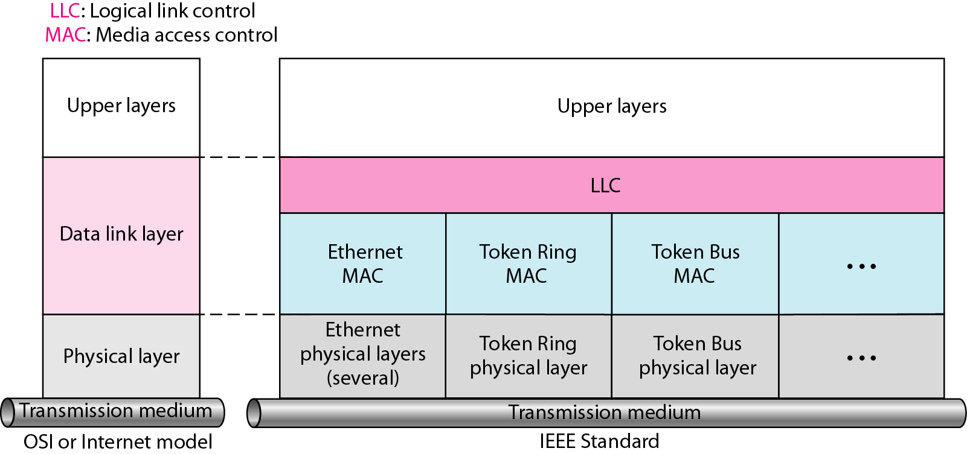
Ethernet Physical Layer :
The Ethernet physical layer is the physical layer component of the Ethernet family which defines the electrical or optical properties of the physical connection between a device and the network or between network devices.
The Ethernet physical layer evolved over a considerable time span and encompasses quite a few physical media interfaces and several magnitudes of speed. The speed ranges from 1 Mbit/s to 100 Gbit/s, while the physical medium can range from bulky coaxial cable to twisted pair and optical fiber. In general, network stack software will work similarly on all physical layers.
The physical layer is dependent on the implementation and type of physical media used. IEEE defines detailed specifications for each LAN implementation. For example, although there is only one MAC sub layer for Standard Ethernet, there is a different physical layer specifications for each Ethernet implementations

STANDARD ETHERNET :

The original Ethernet was created in 1976 at Xerox's Pa10 Alto Research Center (PARC). Since then, it has gone through four generations: Standard Ethernet (10t Mbps), Fast Ethernet (100 Mbps), Gigabit Ethernet (l Gbps), and Ten-Gigabit Ethernet (l0 Gbps), as shown in Figure.
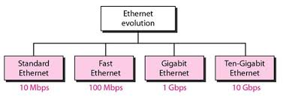
MAC Sub layer :
In Standard Ethernet, the MAC sub layer governs the operation of the access method. It also frames data received from the upper layer and passes them to the physical layer.
Frame Format
The Ethernet frame contains seven fields: preamble, SFD, DA, SA, length or type of protocol data unit (PDU), upper-layer data, and the CRe. Ethernet does not provide any mechanism for acknowledging received frames, making it what is known as an unreliable medium. Acknowledgments must be implemented at the higher layers. The format of the MAC frame is shown in Figure
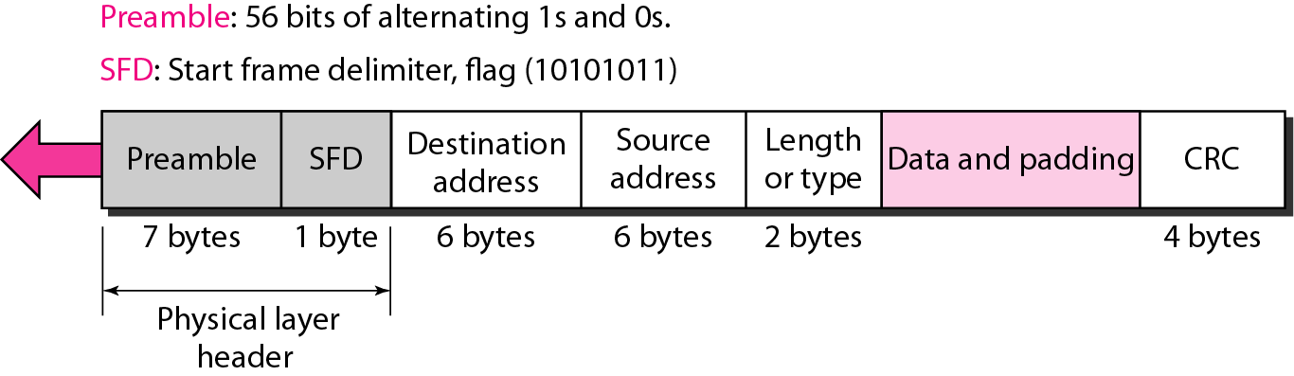
- Preamble. The first field of the 802.3 frame contains 7 bytes (56 bits) of alternating Os and Is that alerts the receiving system to the coming frame and enables it to synchronize its input timing. The pattern provides only an alert and a timing pulse.The 56-bit pattern al10ws the stations to miss some bits at the beginning of the frame. The preamble is actually added at the physical layer and is not (formally) part of the frame.
- Start frame delimiter (SFD). The second field (l byte: 10101011) signals the beginning of the frame. The SFD warns the station or stations that this is the last chance for synchronization. The last 2 bits is 11 and alerts the receiver that the next field is the destination address.
- Destination address (DA). The DA field is 6 bytes and contains the physical address of the destination station or stations to receive the packet. We will discuss addressing shortly.
- Source address (SA). The SA field is also 6 bytes and contains the physical address of the sender of the packet. We will discuss addressing shortly.
- Length or type. This field is defined as a type field or length field. The original Ethernet used this field as the type field to define the upper-layer protocol using the MAC frame. The IEEE standard used it as the length field to define the number of bytes in the data field. Both uses are common today.
- Data. This field carries data encapsulated from the upper-layer protocols. It is a minimum of 46 and a maximum of 1500 bytes, as we will see later.
- FCS (CRC). The last field contains error detection information, in this case a CRC-32

Frame Length :

Ethernet has imposed restrictions on both the minimum and maximum lengths of a frame, as shown in Figure
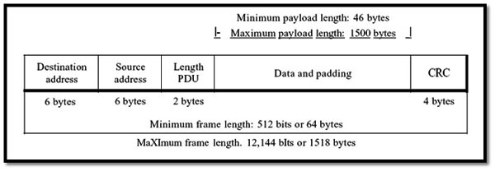
Minimum: 64 bytes (512 bits) Maximum: 1518 bytes (12,144 bits)

The minimum length restriction is required for the correct operation of CSMA/CD as we will see shortly. An Ethernet frame needs to have a minimum length of 512 bits or 64 bytes. Part of this length is the header and the trailer. If we count 18 bytes of header and trailer (6 bytes of source address, 6 bytes of destination address, 2 bytes of length or type, and 4 bytes of CRC), then the minimum length of data from the upper layer is 64 - 18 = 46 bytes. If the upper-layer packet is less than 46 bytes, padding is added to make up the difference.

The standard defines the maximum length of a frame (without preamble and SFD field) as 1518 bytes. If we subtract the 18 bytes of header and trailer, the maximum length of the pay10ad is 1500 bytes. The maximum length restriction has two historical reasons. First, memory was very expensive when Ethernet was designed: a maximum length restriction helped to reduce the size of the buffer. Second, the maximum length restriction prevents one station from monopolizing the shared medium, b10cking other stations that have data to send

Addressing :

Each station on an Ethernet network (such as a PC, workstation, or printer) has its own network interface card (NIC). The NIC fits inside the station and provides the station with a 6-byte physical address. As shown in Figure 13.6, the Ethernet address is 6 bytes (48 bits), nominally written in hexadecimal notation, with a co10n between the bytes.

Example of an Ethernet address in hexadecimal notation

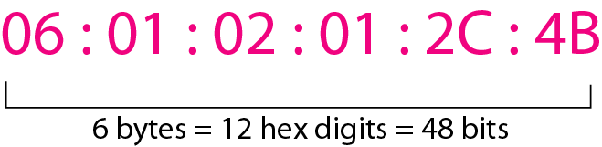

Unicast, Multicast, and Broadcast Addresses.

A source address is always a unicast address-the frame comes from only one station. The destination address, however, can be unicast, multicast, or broadcast. Figure shows how to distinguish a unicast address from a multicast address.
If the least significant bit of the first byte in a destination address is 0, the address is unicast; otherwise, it is multicast.

- A unicast destination address defines only one recipient; the relationship between the sender and the receiver is one-to-one.
- A multicast destination address defines a group of addresses; the relationship between the sender and the receivers is one-to-many.
- The broadcast address is a special case of the multicast address; the recipients are all the stations on the LAN. A broadcast destination address is forty-eight Is.

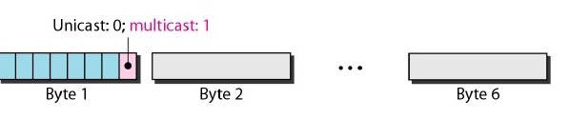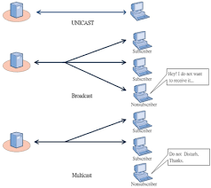
The Standard Ethernet defines several physical layer implementations; four of the most common, are shown in Figure
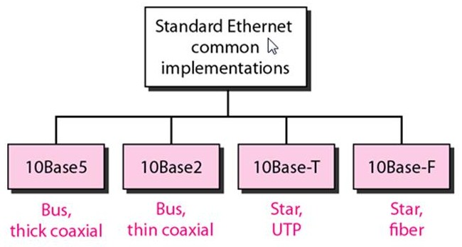

Encoding and Decoding

All standard implementations use digital signaling (baseband) at 10 Mbps. At the sender, data are converted to a digital signal using the Manchester scheme; at the receiver, the received signal is interpreted as Manchester and decoded into data. As we saw in Chapter 4, Manchester encoding is self-synchronous, providing a transition at each bit interval. Figure shows the encoding scheme for Standard Ethernet.

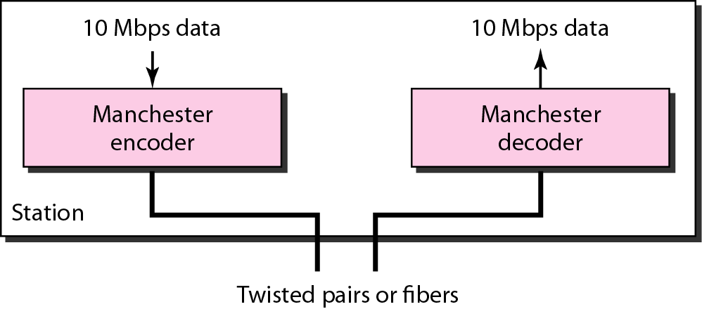
10Base5: Thick Ethernet :

The first implementation is called 10BaseS, thick Ethernet, or Thick net. The nickname derives from the size of the cable, which is roughly the size of a garden hose and too stiff to bend with your hands. 10BaseS was the first Ethernet specification to use a bus topology with an external transceiver (transmitter/receiver) connected via a tap to a thick coaxial cable. Figure shows a schematic diagram of a 10Base5 implementation.

The transceiver is responsible for transmitting, receiving, and detecting collisions. The transceiver is connected to the station via a transceiver cable that provides separate paths for sending and receiving. This means that collision can only happen in the coaxial cable.

The maximum length of the coaxial cable must not exceed 500 m, otherwise, there is excessive degradation of the signal. If a length of more than 500 m is needed, up to five segments, each a maximum of SOO-meter, can be connected using repeaters.
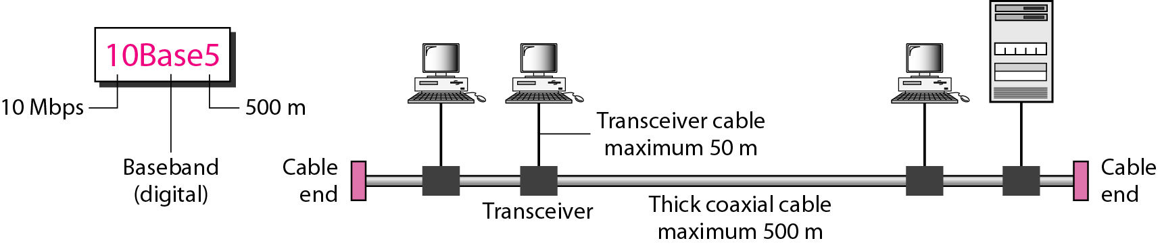

10Base2: Thin Ethernet

The second implementation is called 10Base2, thin Ethernet, or Cheaper net. IOBase2 also uses a bus topology, but the cable is much thinner and more flexible. The cable can be bent to pass very c10se to the stations. In this case, the transceiver is normally part of the network interface card (NIC), which is installed inside the station.

Note that the collision here occurs in the thin coaxial cable. This implementation is more cost effective than 10BaseS because thin coaxial cable is less expensive than thick coaxial and the tee connections are much cheaper than taps. Installation is simpler because the thin coaxial cable is very flexible. However, the length of each segment cannot exceed 185 m (c10se to 200 m) due to the high level of attenuation in thin coaxial cable.

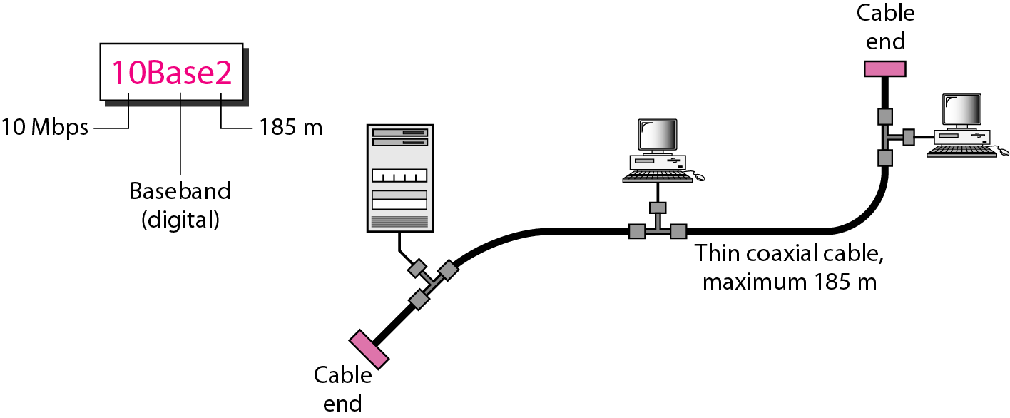

10Base-T: Twisted-Pair Ethernet

The third implementation is called 10Base-T or twisted-pair Ethernet. 1OBase-T uses a physical star topology. The stations are connected to a hub via two pairs of twisted cable, as shown in Figure.

Note that two pairs of twisted cable create two paths (one for sending and one for receiving) between the station and the hub. Any collision here happens in the hub. Compared to 10BaseS or 10Base2, we can see that the hub actually replaces the coaxial

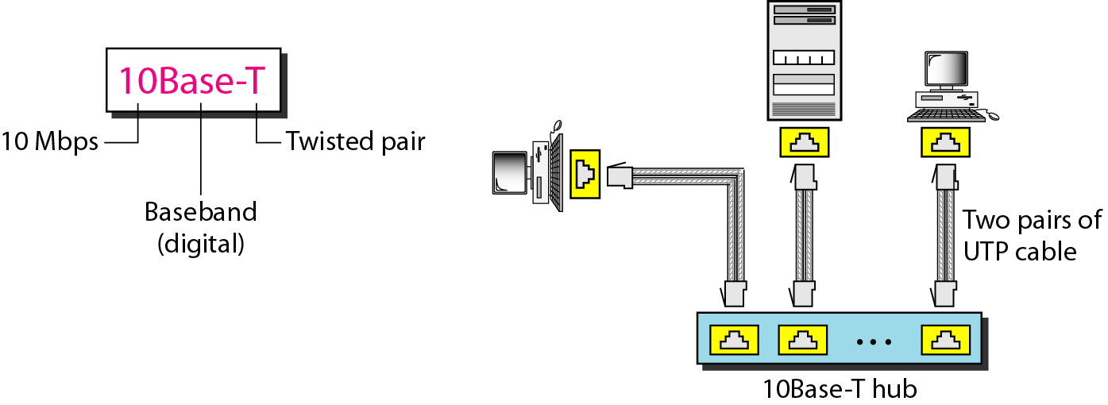
10Base-F: Fiber Ethernet

Although there are several types of optical fiber 10-Mbps Ethernet, the most common is called 10Base-F. 10Base-F uses a star topology to connect stations to a hub. The stations are connected to the hub using two fiber-optic cables, as shown in Figure

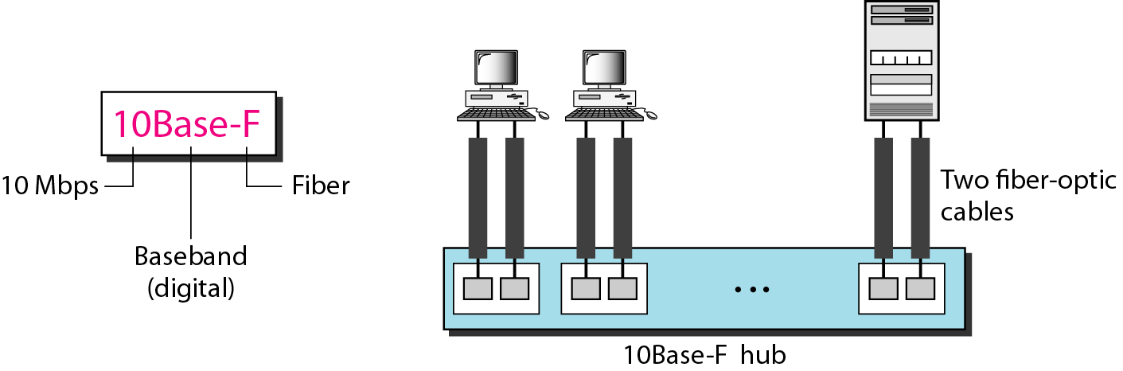

The 10-Mbps Standard Ethernet has gone through several changes before moving to the higher data rates. These changes actually opened the road to the evolution of the Ethernet to become compatible with other high-data-rate LANs.

Ethernet Performance:

Now let us briefly examine the performance of classic Ethernet under conditions of heavy and constant load, that is, with k stations always ready to transmit. A rigorous analysis of the binary exponential back off algorithm is complicated. Instead, we will follow Metcalfe and Boggs (1976) and assume a constant retransmission probability in each slot. If each station transmits during a contention slot with probability p, the probability A that some station acquires the channel in that slot is

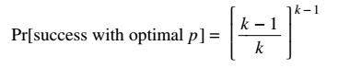(4)
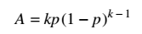(5)
A is maximized when p = 1/k, with A → 1/e as k → ∞. The probability that the contention interval has exactly j slots in it is A(1 − A) j − 1, so the mean number of slots per contention is given by

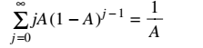
Since each slot has a duration 2τ, the mean contention interval, w, is 2τ/A. Assuming optimal p, the mean number of contention slots is never more than e, so w is at most 2τe ∼∼ 5.4τ.

If the mean frame takes P sec to transmit, when many stations have frames to send,

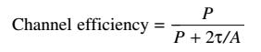(6)

Here we see where the maximum cable distance between any two stations enters into the performance figures. The longer the cable, the longer the contention interval, which is why the Ethernet standard specifies a maximum cable length. It is instructive to formulate Eq. (4-6) in terms of the frame length, F, the network bandwidth, B, the cable length, L, and the speed of signal propagation, c, for the optimal case of e contention slots per frame. With P = F/B, becomes

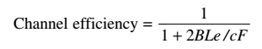(7)

When the second term in the denominator is large, network efficiency will be low. More specifically, increasing network bandwidth or distance (the BL product)reduces efficiency for a given frame size. Unfortunately, much research on network hardware is aimed precisely at increasing this product. People want high bandwidth over long distances (fiber optic MANs, for example), yet classic Ethernet implemented in this manner is not the best system for these applications. We will see other ways of implementing Ethernet in the next section. In Fig. 4-16, the channel efficiency is plotted versus the number of ready stations for 2τ = 51.2 μsec and a data rate of 10 Mbps, using Eq. (4-7). With a 64byte slot time, it is not surprising that 64-byte frames are not efficient. On the other hand, with 1024-byte frames and an asymptotic value of e 64-byte slots per contention interval, the contention period is 174 bytes long and the efficiency is 85%. This result is much better than the 37% efficiency of slotted ALOHA.
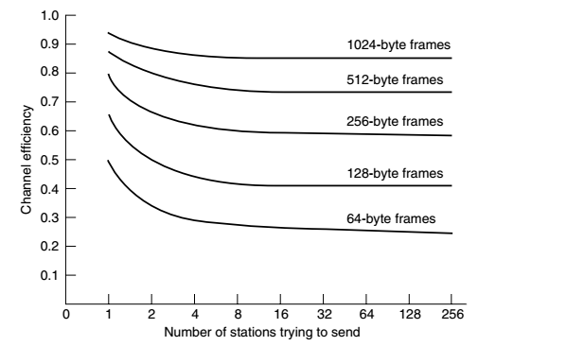
It is probably worth mentioning that there has been a large amount of theoretical performance analysis of Ethernet (and other networks). Most of the results should be taken with a grain (or better yet, a metric ton) of salt, for two reasons.

First, virtually all of the theoretical work assumes Poisson traffic. As researchers have begun looking at real data, it now appears that network traffic is rarely Poisson. Instead, it is self-similar or bursty over a range of time scales (Paxson and Floyd, 1995; and Leland et al., 1994). What this means is that averaging over long periods of time does not smooth out the traffic. As well as using question able models, many of the analyses focus on the ‘‘interesting’’ performance cases of abnormally high load. Boggs et al. (1988) showed by experimentation that Ethernet works well in reality, even at moderately high load.

Bridged Ethernet:

The first step in the Ethernet evolution was the division of a LAN by bridges. Bridges have two effects on an Ethernet LAN: They raise the bandwidth and they separate collision domains.
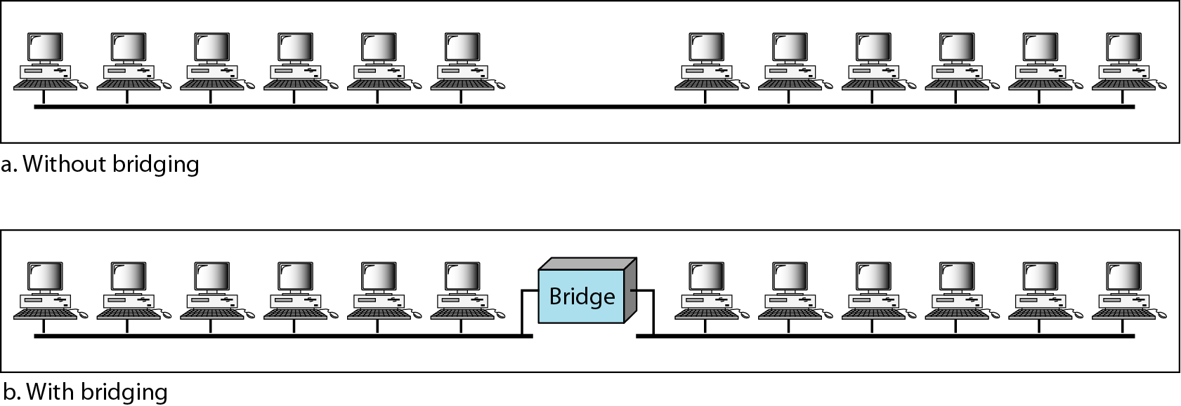

Switched Ethernet:

The idea of a bridged LAN can be extended to a switched LAN. Instead of having two to four networks, why not have N networks, where N is the number of stations on the LAN? In other words, if we can have a multiple-port bridge, why not have an N-port switch? In this way, the bandwidth is shared only between the station and the switch (5 Mbps each). In addition, the collision domain is divided into N domains.

A layer 2 switch is an N-port bridge with additional sophistication that al10ws faster handling of the packets. Evolution from a bridged Ethernet to a switched Ethernet was a big step that opened the way to an even faster Ethernet, as we will see.

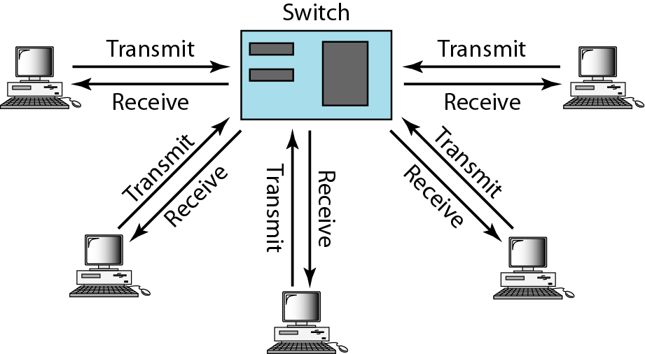
Full-Duplex Ethernet :

One of the limitations of 10Base5 and 10Base2 is that communication is half-duplex (10 Base-T is always full-duplex); a station can either send or receive, but may not do both at the same time. The next step in the evolution was to move from switched Ethernet to full-duplex switched Ethernet. The full-duplex mode increases the capacity of each domain from 10 to 20 Mbps. Figure shows a switched Ethernet in full-duplex mode. Note that instead of using one link between the station and the switch, the configuration uses two links: one to transmit and one to receive.

FAST ETHERNET :

Fast Ethernet was designed to compete with LAN protocols such as FDDI or Fiber Channel (or Fiber Channel, as it is sometimes spelled). IEEE created Fast Ethernet under the name 802.3u. Fast Ethernet is backward-compatible with Standard Ethernet, but it can transmit data 10 times faster at a rate of 100 Mbps. The goals of Fast Ethernet can be summarized as fol10ws:
1. Upgrade the data rate to 100 Mbps.
2. Make it compatible with Standard Ethernet.
3. Keep the same 48-bit address.
4. Keep the same frame format.
5. Keep the same minimum and maximum frame lengths.

MAC Sub layer

A main consideration in the evolution of Ethernet from 10 to 100 Mbps was to keep the MAC sub layer untouched. However, a decision was made to drop the bus topo10gies and keep only the star topology. For the star topology, there are two choices, as we saw before: half duplex and full duplex.
In the half-duplex approach, the stations are connected via a hub; in the full-duplex approach, the connection is made via a switch with buffers at each port.
The access method is the same (CSMA/CD) for the half-duplex approach; for full duplex
Fast Ethernet, there is no need for CSMA/CD. However, the implementations keep CSMA/CD for backward compatibility with Standard Ethernet.

Auto Negotiation :

A new feature added to Fast Ethernet is called auto negotiation. It al10ws a station or a hub a range of capabilities. Auto negotiation al10ws two devices to negotiate the mode or data rate of operation. It was designed particularly for the fol10wing purposes:
- To al10w incompatible devices to connect to one another. For example, a device with a maximum capacity of 10 Mbps can communicate with a device with a 100 Mbps capacity (but can work at a 10wer rate).
- To al10w one device to have multiple capabilities.
- To al10w a station to check a hub's capabilities.

Physical Layer :

The physical layer in Fast Ethernet is more complicated than the one in Standard Ethernet. We briefly discuss some features of this layer.

Topology

Fast Ethernet is designed to connect two or more stations together. If there are only two stations, they can be connected point-to-point. Three or more stations need to be connected in a star topology with a hub or a switch at the center, as shown in Figure

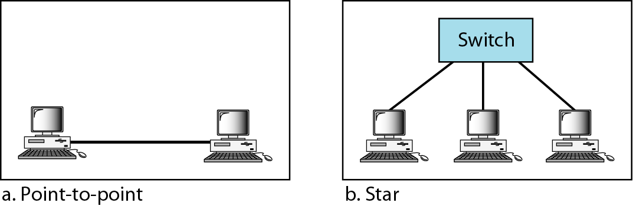

Implementation:

Fast Ethernet implementation at the physical layer can be categorized as either two-wire or four-wire. The two-wire implementation can be either category 5 UTP (100Base-TX) or fiber-optic cable (100Base-FX). The four-wire implementation is designed only for category 3 UTP (l00Base-T4).

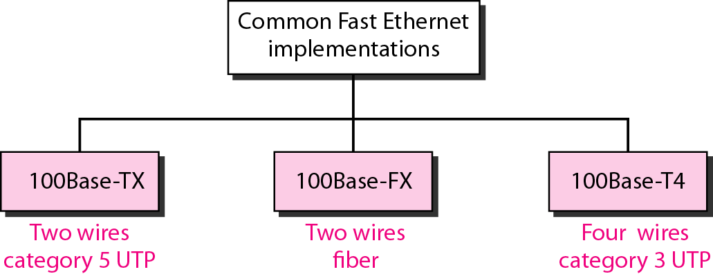

Encoding:

Manchester encoding needs a 200-Mbaud bandwidth for a data rate of 100 Mbps, which makes it unsuitable for a medium such as twisted-pair cable. For this reason, the Fast Ethernet designers sought some alternative encoding/decoding scheme. However, it was found that one scheme would not perform equally well for all three implementations. Therefore, three different encoding schemes were chosen

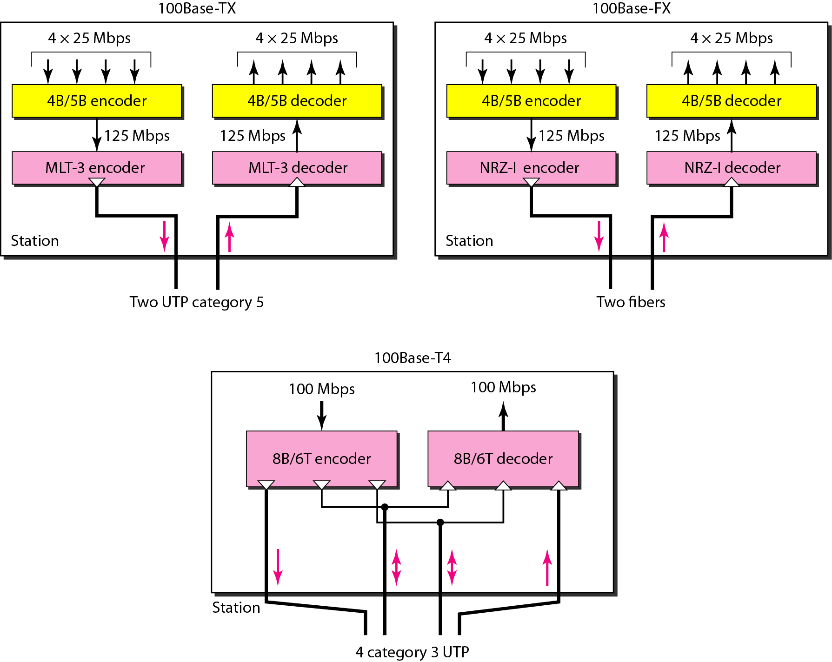
100 Base-TX uses two pairs of twisted-pair cable (either category 5 UTP or STP). For this implementation, the MLT-3 scheme was selected since it has good bandwidth performance (see Chapter 4). However, since MLT-3 is not a self-synchronous line coding scheme, 4B/5B b10ck coding is used to provide bit synchronization by preventing the occurrence of a 10ng sequence of Os and Is. This creates a data rate of 125 Mbps, which is fed into MLT-3 for encoding.

100 Base-FX uses two pairs of fiber-optic cables. Optical fiber can easily handle high bandwidth requirements by using simple encoding schemes. The designers of 100Base-FX selected the NRZ-I encoding scheme for this implementation. However, NRZ-I has a bit synchronization problem for 10ng sequences of Os (or Is, based on the encoding),

To overcome this problem, the designers used 4B/5B b10ck encoding as we described for IOO Base-TX. The b10ck encoding increases the bit rate from 100 to 125 Mbps, which can easily be handled by fiber-optic cable. A 1OOBase-TX network can provide a data rate of 100 Mbps, but it requires the use of category 5 UTP or STP cable. This is not cost-efficient for buildings that have already been wired for voice-grade twisted-pair (category3).

A new standard, called 100Base-T4, was designed to use category 3 or higher UTP. The implementation uses four pairs of UTP for transmitting 100 Mbps. Encoding/decoding in 100Base-T4 is more complicated. As this implementation uses category 3 UTP, each twisted-pair cannot easily handle more than 25 M baud. In this design, one pair switches between sending and receiving.
Three pairs of UTP category 3, however, can handle only 75 M baud (25 M baud) each. We need to use an encoding scheme that converts 100 Mbps to a 75 M baud signal. As we saw in Chapter 4, 8B/6T satisfies this requirement. In 8B/6T, eight data elements are encoded as six signal elements. This means that 100 Mbps uses only (6/8) x 100 Mbps, or 75 M baud.

GIGABIT ETHERNET:

The need for an even higher data rate resulted in the design of the Gigabit Ethernet protocol (1000 Mbps). The IEEE committee calls the Standard 802.3z. The goals of the Gigabit Ethernet design can be summarized as fol10ws:

1. Upgrade the data rate to 1 Gbps.
2. Make it compatible with Standard or Fast Ethernet.
3. Use the same 48-bit address.
4. Use the same frame format.
5. Keep the same minimum and maximum frame lengths.
6. To support auto negotiation as defined in Fast Ethernet.

MAC Sub layer

A main consideration in the evolution of Ethernet was to keep the MAC sub layer untouched. However, to achieve a data rate 1 Gbps, this was no 10nger possible. Gigabit Ethernet has two distinctive approaches for medium access: half-duplex and full-duplex. Almost all implementations of Gigabit Ethernet fol10w the full-duplex approach. However, we briefly discuss the half-duplex approach to show that Gigabit Ethernet can be compatible with the previous generations.

Full-Duplex Mode:

In full-duplex mode, there is a central switch connected to all computers or other switches. In this mode, each switch has buffers for each input port in which data are stored until they are transmitted. There is no collision in this mode, as we discussed before. This means that CSMA/CD is not used. Lack of collision implies that the maximum length of the cable is determined by the signal attenuation in the cable, not by the collision detection process.

Half-Duplex Mode

Gigabit Ethernet can also be used in half-duplex mode, although it is rare. In this case, a switch can be replaced by a hub, which acts as the common cable in which a collision might occur. The half-duplex approach uses CSMA/CD. However, as we saw before, the maximum length of the network in this approach is totally dependent on the minimum frame size. Three methods have been defined: traditional, carrier extension, and frame bursting.

Traditional In the traditional approach, we keep the minimum length of the frame as in traditional Ethernet (512 bits). However, because the length of a bit is 11100 shorter in Gigabit Ethernet than in 10-Mbps Ethernet, the s10t time for Gigabit Ethernet is 512 bits x 111000 JlS, which is equal to 0.512 JlS. The reduced s10t time means that collision is detected 100 times earlier. This means that the maximum length of the network is 25 m. This length may be suitable if all the stations are in one room, but it may not even be 10ng enough to connect the computers in one single office. Carrier Extension To al10w for a 10nger network, we increase the minimum frame length.
The carrier extension approach defines the minimum length of a frame as 512 bytes(4096 bits). This means that the minimum length is 8 times 10nger. This method forces a station to add extension bits (padding) to any frame that is less than 4096 bits. In this way, the maximum length of the network can be increased 8 times to a length of 200 m. This allows a length of 100 m from the hub to the station. Frame Bursting Carrier extension is very inefficient if we have a series of short frames to send; each frame carries redundant data.
To improve efficiency, frame bursting was proposed. Instead of adding an extension to each frame, multiple frames are sent. However, to make these multiple frames 100k like one frame, padding is added between the frames (the same as that used for the carrier extension method) so that the channel is not idle. In other words, the method deceives other stations into thinking that a very large frame has been transmitted

Physical Layer :

The physical layer in Gigabit Ethernet is more complicated than that in Standard or Fast Ethernet. We briefly discuss some features of this layer.

Topology :

Gigabit Ethernet is designed to connect two or more stations. If there are only two stations, they can be connected point-to-point. Three or more stations need to be connected in a star topology with a hub or a switch at the center. Another possible configuration is to connect several star topo10gies or let a star topology be part of another as shown in Figure
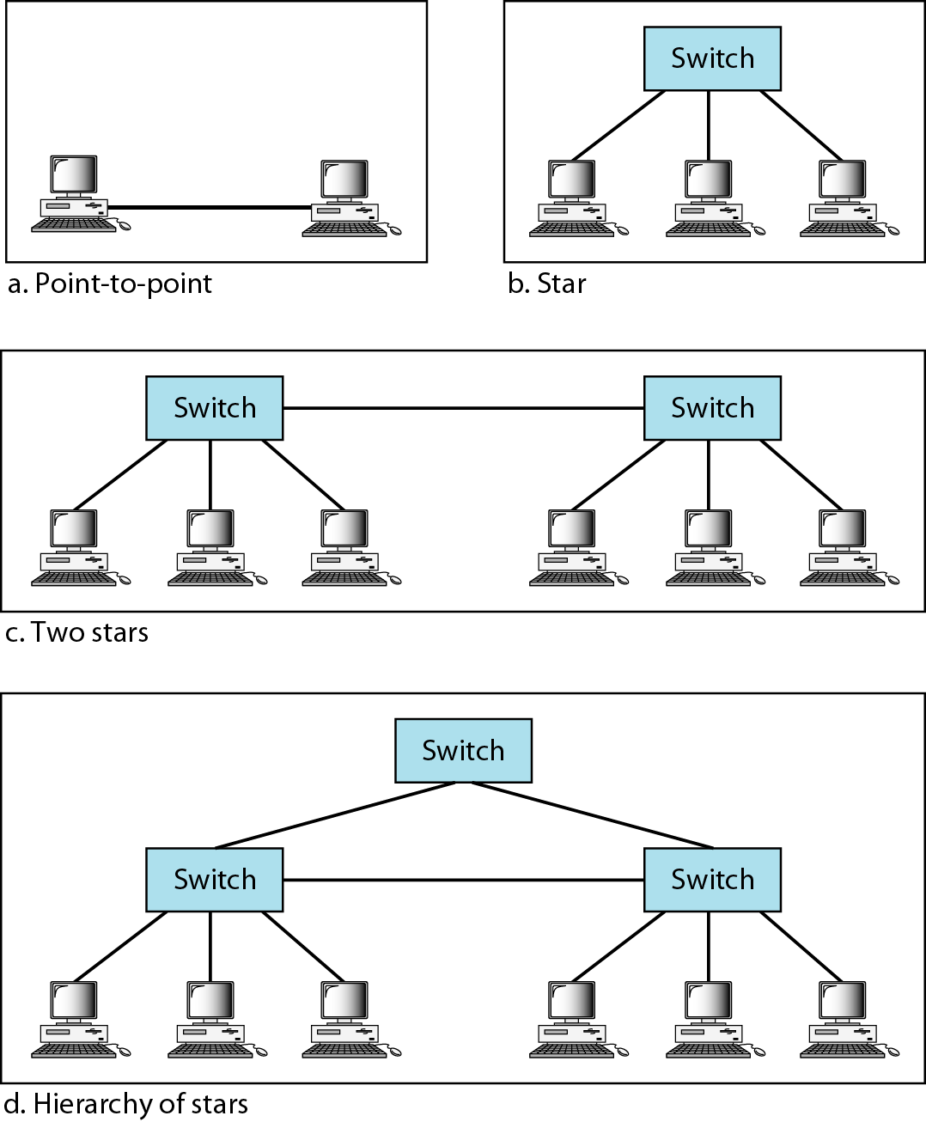

Implementation :

Gigabit Ethernet can be categorized as either a two-wire or a four-wire implementation. The two wire implementations use fiber-optic cable (1000Base-SX, short-wave, or 1000Base-LX, 10ng wave), or STP (1000Base-CX). The four-wire version uses category5 twisted-pair cable (1000Base-T). In other words, we have four implementations; 1000Base-T was designed in response to those users who had already installed this wiring for other purposes such as Fast Ethernet or telephone services.

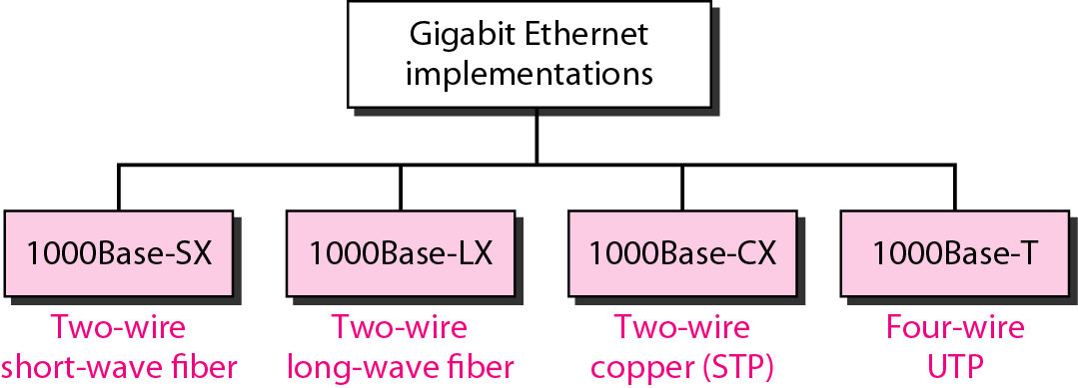

Encoding in Gigabit Ethernet implementations

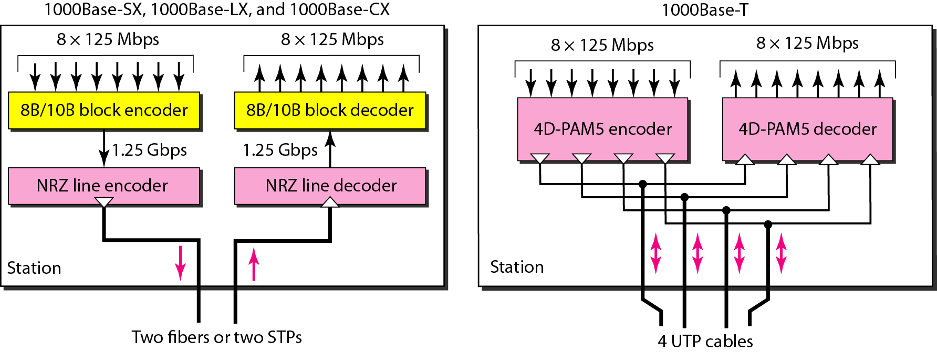

Gigabit Ethernet cannot use the Manchester encoding scheme because it involves a very high bandwidth (2 G Baud). The two-wire implementations use an NRZ scheme, but NRZ does not self synchronize properly. To synchronize bits, particularly at this high data rate, 8BIl OB b10ck encoding, discussed in Chapter 4, is used.
This b10ck encoding prevents 10ng sequences of Os or Is in the stream, but the resulting stream is 1.25 Gbps. Note that in this implementation, one wire (fiber or STP) is used for sending and one for receiving.
In the four-wire implementation it is not possible to have 2 wires for input and 2 for output, because each wire would need to carry 500 Mbps, which exceeds the capacity for category 5 UTP. As a solution, 4D-PAM5 encoding, as discussed in Chapter 4, is used to reduce the bandwidth. Thus, all four wires are involved in both input and output; each wire carries 250 Mbps, which is in the range for category 5 UTP cable

